Ali Banisadr: The Alchemist

March 16 – June 29, 2025

**Docent Training Day 1**

Docent Notes prepared by Nancy Hazelton and Mary Rosewater

# Introduction to the Exhibition (Liz Monti, KMA Associate Curator):

*Ali Banisadr: The Alchemist*, curated by KMA Director and Chief Curator Michelle Yun Mapplethorpe, is the first major US museum survey of Banisadr’s work. Spanning nearly twenty years of Banisadr’s practice, it features his early works of the 2000s, breakthrough paintings of the 2010s, and the mature work he is currently producing. Banisadr has been included in a number of important group exhibitions such as *Iran Modern*, at Asia Society, New York (2013-2014), and has been the subject of international monographic exhibitions at

commercial galleries, as well as thematically-focused solo museum exhibitions, including *Bosch and Banisadr: We Work in Shadows*, at the Gemäldegalerie, Academy of Fine Arts, Vienna, Austria (2019). The presentation at the KMA offers an opportunity to encounter the artist at mid-career, presenting a comprehensive overview of his work from 2006 to the present. It features a range of media, from drawings and prints to paintings and newly created, never-before-seen sculpture. The exhibition explores Banisadr’s methods, techniques and the vast range of art historical references that inform his work. After the KMA, the exhibition will tour to other venues across the United States.

The exhibition will be accompanied by a catalogue with critical essays by Dr. Gražina Subelytė, Associate Curator, Peggy Guggenheim Collection; Dr. Bill Sherman, Director, The Warburg Institute, University of London; and Michelle Yun Mapplethorpe, Director, Katonah Museum of Art. It will also feature a transcribed

conversation with the artist and noted art historian Robert Storr, and a fully illustrated plate section.

# Ali Banisadr HeadshotIntroduction to Ali Banisadr:

Standing in front of a work in progress, Ali Banisadr views it from multiple distances as he paints. When it hangs on a gallery wall, he wants the viewer to

likewise move about, to see the painting from

differing perspectives. At first, the images may seem largely abstract, a riot of shape and color. But close regard reveals figures, some complete, some

fragmented. Even closer focus suggests connections among those figures, and a world with a narrative-- perhaps ambiguous--emerges from the apparent chaos.

Ali Banisadr draws on a complex background to create his painted worlds. Born in Tehran in 1976, he lived within the physical ruins of Iran’s conflict in the 70s and 80s; as a child, drawing was for him a “safe place.” In the Conversation with Robert Storr from the catalogue for this exhibition, Banisadr says of this time:

“I remember mostly sounds and vibrations, but there were some things that I saw, too. Mostly ruins,

like a building that you see one day and then the next day it’s cut in half, and you look at it, and you can see the wallpaper. Half there, half not there. One instance that I remember clearly: a bomb dropped in the yard of my school where we always played, but the bomb hadn’t gone off. It was dropped

overnight. But the next day I saw it, and there was this giant hole in the ground. I remember this really clearly. It had such an impact in some of the earlier paintings I made.”

When he was twelve, his family emigrated and settled in California; drawing, he says, helped him untangle the new culture he was thrust into, and he fell in with a pack of graffiti artists. Recognizing that he needed to “take it seriously,” he moved to New York after high school to study at the School of Visual Arts, and then the New

York Academy of Art (MFA 2007).

In his studio in Brooklyn, Banisadr’s research table, crowded with images and texts, attests to his trans-global, trans-historical explorations as he prepares to paint. Art-historical figures and periods butt up against each other—a tome on Persian miniatures may be open next to one on Paul Cezanne (d. 1906), or Pieter Brueghel (d. 1569), or Willem de Kooning (d. 1997). Banisadr will be reading them all at the same time. He is

interested, he says, in the “space between these books and how they connect” in his own mind. Along with types inspired by his research, the figures in his epic landscapes will likely include references to personal history, current events, and literature. He entitles his works with intention; these are important, he explains, because they have to capture all his ideas and research.

Although he may be consulting multiple texts simultaneously, they are all in service to a specific project: he works on only one painting at a time. “I don’t start with sketches; my process is initially abstract, performative, and energetic. Gradually, as I engage with the canvas, certain elements begin to resonate with me. It

becomes a negotiation, as the work slowly unveils its story and shares its narrative with me.”

Banisadr’s artistic process is conditioned in part by his synesthesia, a neural phenomenon that causes multiple senses to activate each other. In his case, color and form stimulate not only vision, but sound as well. “I hear a lot of sounds from the work [They] pull me in to make things come out, and they have to all go together in

a kind of orchestra. I imagine it all as air running through, and I’m just trying to open up chambers to let the air flow, so it doesn’t get stuck.”

In his early works, Banisadr conducts that “orchestra” from on high. Typically, his formative works feature bird’s eye, or aerial, perspective: the viewer regards the landscape from above. More recent work—less figurative—shifts the viewing perspective lower.

Ali Banisadr’s work has been seen in exhibitions around the world —in Berlin, Athens, Florence, Paris, London, and Shanghai, among others. This is his first solo American museum survey.

# Untitled Charcoal Series, 2006

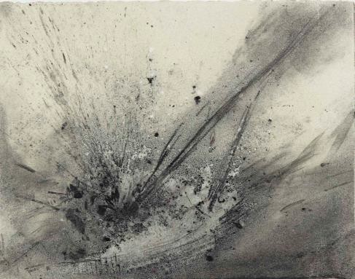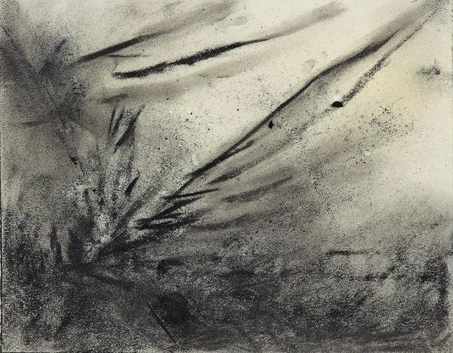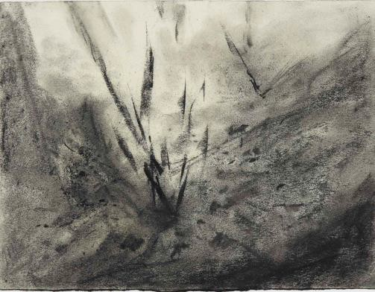

*Untitled*, 2006 Charcoal on paper

7 x 9.5 in. (17.8 x 24.1 cm)

Collection of the artist

*Untitled*, 2006 Charcoal on paper

7 x 9.5 in. (17.8 x 24.1 cm)

Collection of the artist

*Untitled*, 2006 Charcoal on paper

7 x 9.5 in. (17.8 x 24.1 cm)

Collection of the artist

While Ali Banisadr was a graduate student at the New York Academy of Arts, he traveled to Normandy, and he walked the beaches on which allied forces landed, D-Day 1944. In the presence of such an historic and consequential battle site, he was moved by the ghosts of WWII, which merged with memories of his own intense childhood living through the Iranian Revolution and the Iran-Iraq War.

He recalls a visceral response, like an hallucination, of “being able to hear the whistling and banging, feeling everything within my body as if it were real.” When he returned to his New York studio, that experience was captured in a series of charcoal sketches; three appear in our exhibition.

In quick renderings, Banisadr strives to recreate on paper the deafening sound of explosions. These works, he says, are “more real than anything done before, more free and instantaneous. . . I was really feeling these drawings in my body.”

Bold diagonal slashes, surrounded by a sfumato haze, belch out from the foreground point of explosion and fill the frame. Together, the three works form a cinematic rendering of deadly conflict, and the viewer can almost hear, with Banisadr, the thunder of war.

*The Waste Land*, also done in 2006, is perhaps the technicolor sequel to these charcoals. Although in all

iterations, we view the action from an elevated perspective, we are uncomfortably close to the blasts in the

sketches. In *The Waste Land,* a lone figure wanders the field of battle--between us and the detonations—and so we feel safer in that version.

# A drawing of a person in a dress Description automatically generatedUntitled Ink on Paper Pair, 2006

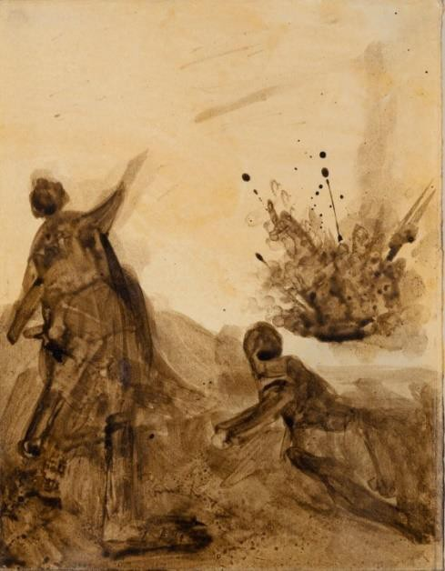*Untitled*, 2006 (left) Ink on paper

9.5 x 7 in. (24.1 x 17.8 cm)

Collection of the artist

*Untitled*, 2006 (right) Ink on paper

9.5 x 7 in. (24.1 x 17.8 cm)

Collection of the artist

Unlike most of Ali Banisadr’s work, which is done in landscape format, these small sketches appear in portrait mode, which befits the standing figures in each. His charcoal sketches feature only the moment of explosion; in these works, however, we see the human cost of those blasts.

Clear narratives emerge in both these ink sketches. In the first one, which is seemingly gendered, a wounded man lies on a pallet on the floor, arms raised in supplication. A nurse tends to him, in her right hand an infusion bag for medicine or fluids. Though her face and upper body are vaguely drawn with looping pencil marks, a

viewer can still discern her attention to the patient: both her head and her body incline to him.

The lower half of her body, covered by a long skirt, is more fully realized and tinted with a sepia wash. Below her, the injured soldier lies clothed and shod, with an apparent bandage encircling his head. Like the *Untitled* charcoals and the accompanying ink sketch, this work is monochromatic: a range of sepia values renders the somber tone of the scene.

Two figures also appear in the second ink sketch, this one set on the battlefield. Although they are in the foreground and the explosion in the rear, these figures are nonetheless perilously close. Banisadr used no

graphite in this work, perhaps because we view them from behind. As they regard the blast, the figure on the right falls to the ground in a self-protective crouch. The stance of the other character, however, is puzzling: how do we read his right-arm gesture? His frontal bravado?

Although rendered in three different media, the explosions in this Normandy series manifest similar features: densely concentrated medium at detonation ground level with verticals projecting debris in the blast wave. All of this carnage leads to the quietest work in the series, the coda--The *Untitled* ink sketch of the nurse tending to the war’s casualty.

***The Waste Land*, 2006**

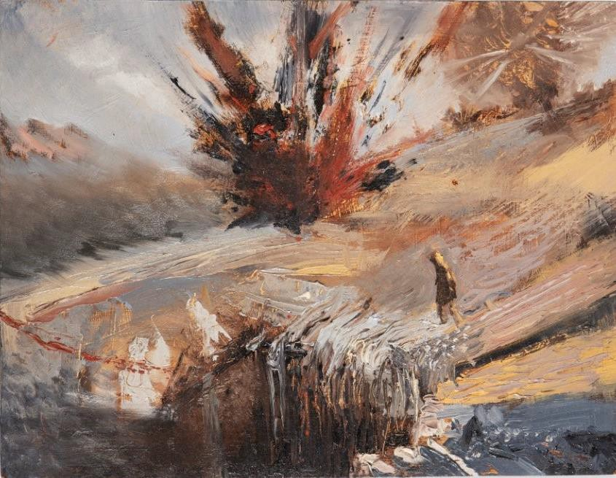

*The Waste Land*, 2006 Oil on panel

9 x 12 in. (22.9 x 30.5 cm) Collection of the artist

In 1922, when T. S. Eliot composed *The Waste Land,* the Western world order had irrevocably changed. In the aftermath of WWI, empires had fallen, the map of Europe had been transformed, and Victorian

certainties—moral, social, and political—had been shaken. As the conflict was ending, a global pandemic claimed more victims than the war itself had. No

wonder Eliot’s poem is hard to understand; it mirrors the reality of its time.

Eliot’s poem speaks to Banisadr’s own experience: first, as a child of conflict, and then as a young immigrant facing an unfamiliar culture. A comparison of two works inspired by this poem can help to illustrate the painter’s evolving style.

Banisadr’s small painting *The Waste Land*, of 2006, shows the young artist’s first reading of the poem, as an anti-war anthem. As with many of his early works, this painting reveals a coherent narrative and a central focus, approaches that Banisadr moves away from in his later practice.

A lone figure walks the battlefield. In the middle ground, drawing the viewer’s eye, a vast explosion spews out red and black debris and fragments; the figure, head bowed, seems oblivious to that blast and another on the right horizon line. Unlike the conflicts depicted in *Contact* and *It’s in the Air*, both of which finely choreograph the violence, in this work it seems random and pointless, as in Banisadr’s charcoal sketches at Normandy.

Here, the thickly applied paint mimics the vibration and sound of bombs, though these explosions are doing scant damage to an already blasted, unpeopled wasteland.

Who, then, is the lone wanderer: a survivor? a deserter? an allegorical everyman? Though he does not seem engaged in the fiery action, he is doomed nonetheless. Our bird’s eye view reveals the rushing waterfall that he is headed for, seemingly unaware. Banisadr’s innate optimism prevails in most of his work; though he may imagine scenes of carnage, they are generally redeemed by some manifestation of hope. Not so in this work, a desolate landscape with a single hopeless figure walking passively toward his fate.

***These fragments I have shored against my ruins*, 2023**

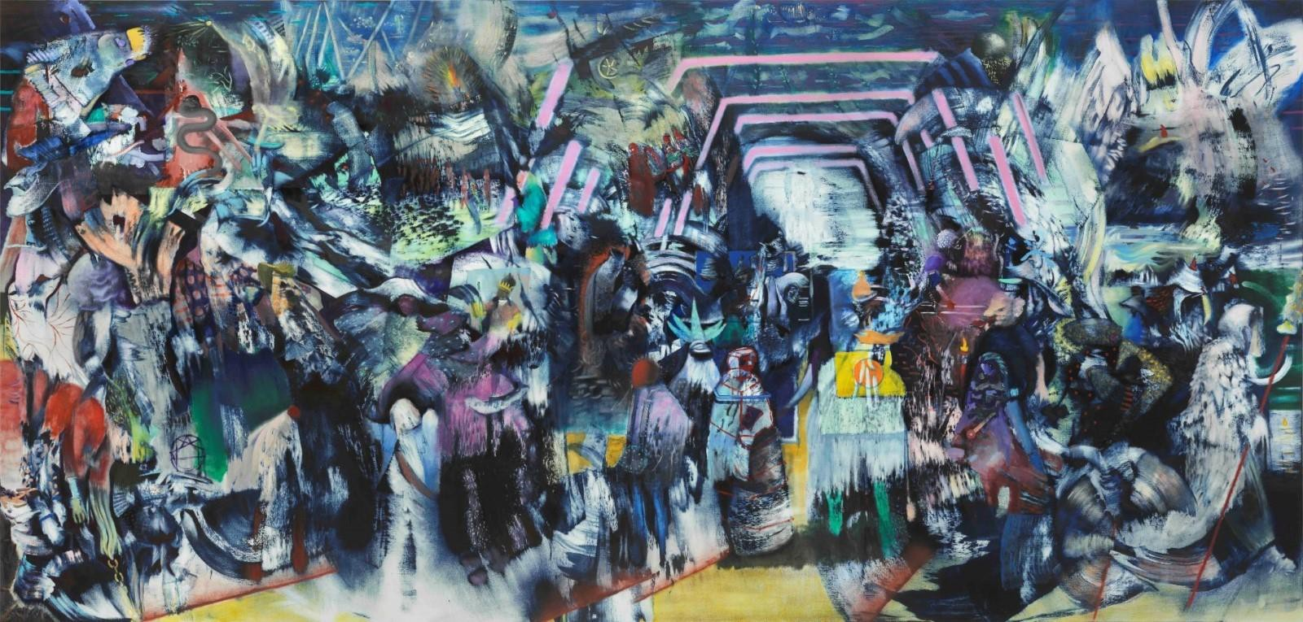

*These fragments I have shored against my ruins*, 2023 Oil on linen

86 x 180 in. (218.4 x 457.2 cm)

Mohammed Afkhami Foundation

In 2023, Banisadr returns to the poem for inspiration. The title he chooses, *These fragments I have shored against my ruin*s*,* quotes a line from the conclusion of poem; it is Eliot’s reflection on what sustains him in the face of utter devastation. In multiple voices throughout the poem, the speaker has described vital “fragments” of global, trans-historical culture; these, he believes, preserve him from despair.

Banisadr’s 2023 painting reveals the artist’s more complex reading of the poem as well as his evolving style.

*These fragments* is monumental (86 x 180 inches), comprehensive, and cryptic, an epic “heap of broken

images” (Eliot I. 22). Rather than the single note of despair in the previous painting, here Banisadr presents a polyphonic chorus manifesting both despair and hope.

Hallmarks of Banisadr’s early approach—landscape markers, a bird’s eye view—are absent in this later

work. In a recent interview, the artist explains the change. His compositional space, he says, has “become more complex than in my earlier works. Instead of a straightforward landscape with clear foreground and

background, I’m embracing a cubist approach. . . an ambiguous space where viewers might feel disoriented— almost like stepping onto a stage with various realms to explore within the painting” (*Artnet* Nov. 2024).

As Eliot provided footnotes to the more obscure references in his poem, Banisadr provided a gloss

(interpretation) on this painting (when it was exhibited at the Victoria Miro Gallery), though I wonder if it will help any viewers enter its “ambiguous space.” *These fragments*, he says, contains “elements of disruption by a

foreign entity, which in my mind is a digital entity, such as AI or social media. I have always been interested in the disruption of technology and how it can change us as human beings to become another type of being.”

Certainly, the past is being “disrupted” in this spectacle: crowned figures appear, quite diminished; a hooded figure stalks the downstage; a serpent coils above the fray. Although Banisadr renders the characters discrete, they are nonetheless densely packed into the compositional space, often overlapping. Amidst all the cool colors, a patch of white paint appears, surrounded by a mauve structure which the artist has identified as a “portal,” perhaps, he suggests, to a modern, digitized world. Is the artist implying that technology will

preserve these broken fragments of history?

In one of his essays, T. S. Eliot explained that “immature poets imitate; mature poets steal. . . [and] make it into something better, or at least something different.” Eliot’s *The Waste Land*, that complex, multivalent ideal of Modernist poetry, confronts a world decentered. Banisadr mines the poem for his own world building, making “something different” in two distinct phases.

***Things Fall Apart*, 2007**

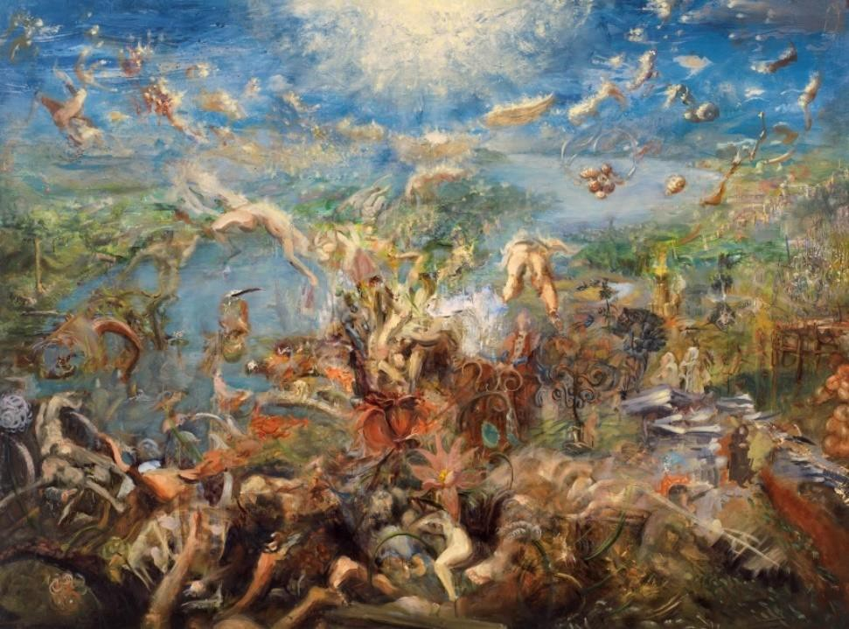*Things Fall Apart*, 2007 Oil on linen

44 x 50 in. (111.8 x 127 cm)

Collection of Jacob Miller

Two works from 2007 can illustrate how Ali Banisadr draws on his disparate influences for the strange worlds that he builds on canvas. *Things Fall Apart* and *The Center Cannot Hold* owe their titles to the oft- quoted W. B. Yeats poem “The Second

Coming” (1919), but their inspiration and composition reflect more directly the

complex worlds of the painter Hieronymus Bosch (d. 1516).

Yeats’s poem, written in response to the carnage of WWI, describes a world undone, where the social, political, and spiritual foundations have been shaken, and “mere anarchy is loosed upon the world.” The narrator anticipates a second coming, but sees no divine messiah. Instead, a “rough beast” with a “gaze blank and pitiless as the sun” is about to be born.

Banisadr’s *Things Fall Apart* likewise presents, from an aerial perspective, a cataclysmic landscape; body parts are piled up in the foreground and fly mid-air throughout the rest of the scene. At the center, some strange

eruption seems to be generating all this carnage; things are indeed falling apart—or perhaps, being blown apart.

***The Center Cannot Hold*, 2007**

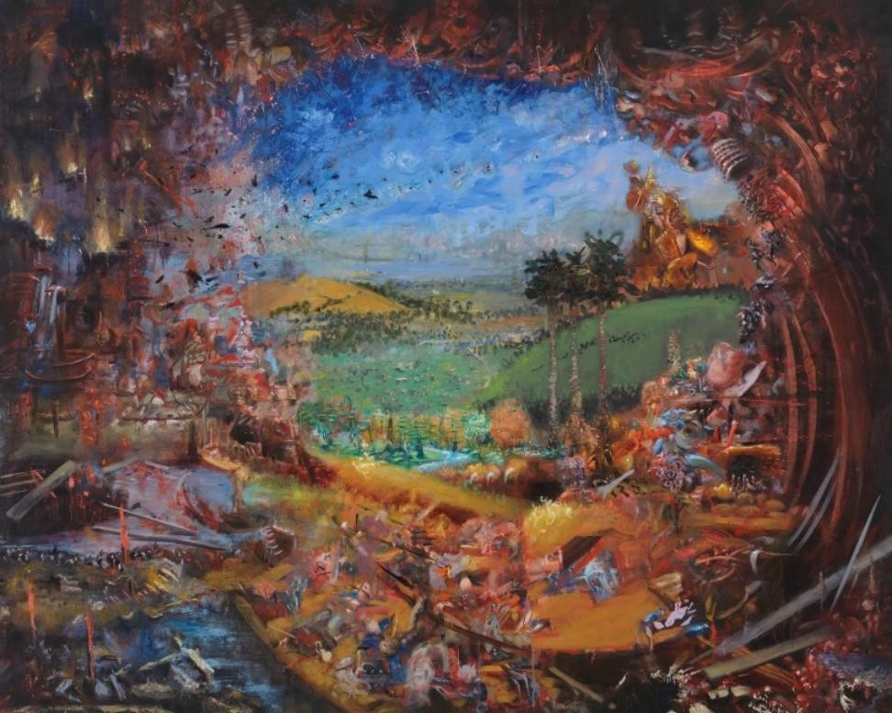*The Center Cannot Hold*, 2007 Oil on linen

48 x 60 in. (121.9 x 152.4 cm)

Franks Family Collection, UK

In *The Center Cannot Hold*, Banisadr

likewise uses a bird’s eye view, but depicts a more pacific world, with rolling green hills and blue sky at center. Framing that

arcadian landscape, however, are more ominous images—partly abstract, partly

figurative, pressing in on that center. Are these the forces of conflict that the artist witnessed as a child in Iran? Or do they speak to contemporary strife?

While these paintings do seem to illustrate their titles, they finally reject the profound despair of Yeats’s

poem. *The Second Coming* sees a world abandoned by God and given over to the beast. Banisadr, a child of war, strives instead to depict worlds that “piece [together] the fragments that remain after societies collapse”; he wants, he says, to “see what lies beyond all the confusion.” He may indeed represent conflict and stress in his paintings, but this artist’s worldview is essentially optimistic: one needs only look to the horizon line in both works, where brilliant blue sky promises redemption.

In Vienna some years ago, Banisadr spent hours in front of *The Last Judgement* (c. 1495-1505) by Bosch, the Northern Renaissance painter that Banisadr cites as influencing his own approach to “world-building.” In this work, the three panels present a harrowing narrative of mankind’s fall from grace. Human creation and sin appear in the first panel, the most conventional in its landscape composition. In the last panel, as in the conclusion of Yeats’s poem, the beasts have taken over; they preside over hell.

The central panel of this triptych presents grotesque bodies engaging in all manners of sin; it certainly seems that things have fallen apart, that we are all damned. But at the apex of this dark rendering, God appears in divine light, surrounded by saints and angels, presiding over this foul carnival—a visual promise that the just will be rewarded.

Banisadr says that he enters Western religious painting without the “baggage” of someone steeped in the

beliefs. As an agnostic, he is not counting on divine intervention, but these two paintings, exhibited first at the Post Graduate Fellows Exhibition at the New York Academy of Art (2008), nonetheless reject existential

despair. In talking about a later show (*Ali Banisadr: The Changing Past*, Victoria Miro II Gallery, 2023*),* Banisadr

explains that his work attempts to find healing from “man-made and natural disasters, violence and conflict,” to confront the chaos of the past and present, in order to visualize a different future.

Consider, for a moment, the color palette used in these two paintings. Banisadr’s synesthesia causes an

overlap in his senses: he sees color, but also hears it; he is, he says, “quite sensitive to color.” In both of these paintings, luminous color hardly portends doom. In *The Center Cannot Hold,”* hints of red—a color the artist associates with danger or anxiety—may frame the central vista, but the viewer’s eye is drawn to the tranquility of the blues and greens within.

*Things Fall Apart* presents a more turbulent world, with figures aloft and in the foreground. But as in the Bosch triptych, an intense glow dominates the center top frame, perhaps a reference to the older work but with a more secular solution to chaos. Banisadr’s philosophy, he explains, inclines toward animism: humankind may wreak havoc, but the universe will sort itself out.

***Black*, 2007**

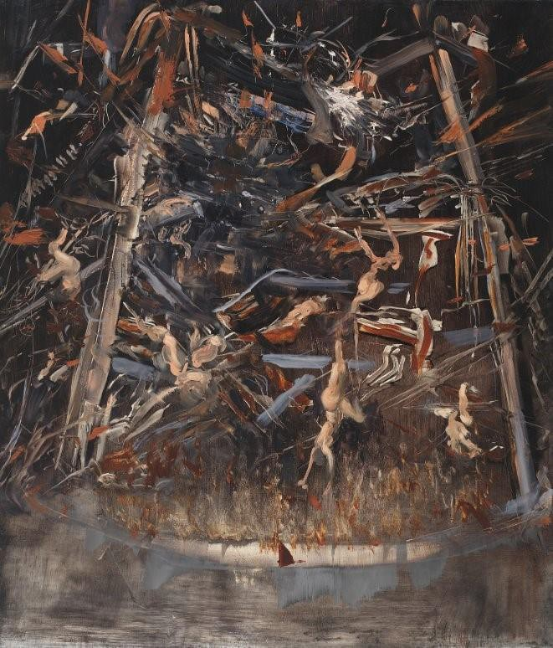

*Black*, 2007 Oil on linen

28 x 24 in. (71.1 x 61 cm) Private collection

Even as his compositional style has evolved, Ali Banisadr has remained a vivid colorist, his worldscapes ablaze with vibrant hues. But these two paintings are shadow-cast, with figures set against inky backgrounds. Despite their somber underpaintings,

these works portray very different subject matter, and lead to quite different emotional responses.

In *Black*, Banisadr engages once again a trope from medieval religious painting, that of bodies falling into torment. We have seen a gentler use of this motif in *Things Fall Apart*, painted in the same year. But in this version, there is scant hope of redemption;

inexorably, the fleshy bodies plummet into the fiery sea below.

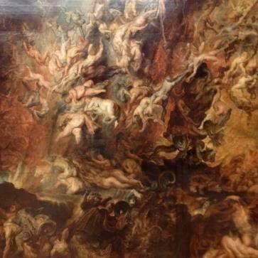Banisadr’s affinity for northern European religious art likely inspired this gruesome scene. A similar use of the trope can be found in Peter Paul Rubens’ *Descent of the Damned into Hell* (1620), but this is hardly the only

example—the motif carries on throughout the religious art of the Renaissance in any number of Last Judgement studies (including Michaelangelo’s on the

wall of the Sistine Chapel).

**NOT IN EXHIBITION**

Peter Paul Rubens

But Banisadr’s interests reside in the events and ideas of the present time as well as of the past. In *Black,* these bodies fall from an architectural

*The Fall of the Damned, ca. 1620*

Oil on canvas

112.6 x 88.19 in (286 x 224 cm)

Alte Pinakothek, Munich, Germany

support of some kind; this fearful scene may remind some viewers of a more recent horror—at the World Trade Center in 2001. In this reading, the tumbling bodies are blameless, but they fall nonetheless.

Banisadr revisits the darker tones later that year with *Black 2*; again in 2009 with *Black 3*, and in 2011 with

*Black 4*; each iteration becomes progressively darker (not in our exhibition).

***Alchemy*, 2015**

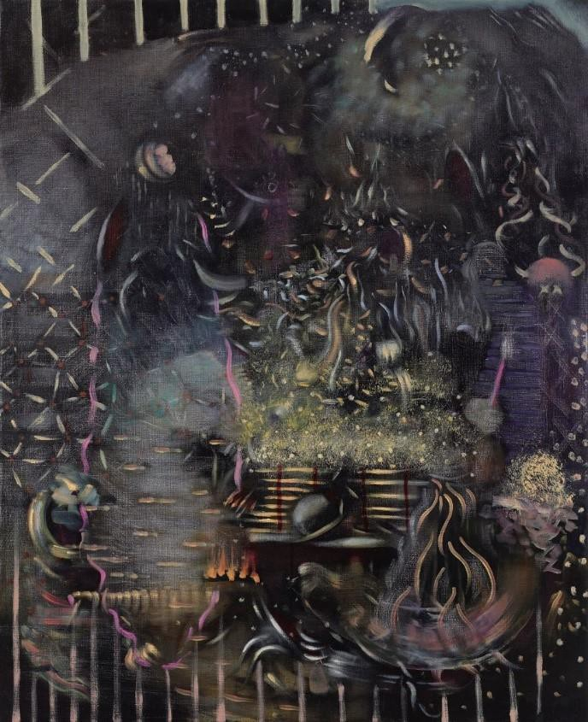Though the figures in *Alchemy* (2015) emerge from a funereal

background as well, the emotional tenor of this work is decidedly more positive, with the energy ascending rather than falling. As noted earlier, Banisadr’s titles often provide a pathway into his

works; titles, he says, “capture all ideas and research” that lead to a specific painting. Consider this title*: Alchemy,* which refers literally to the medieval and early Modern pseudoscience of transmuting base metal into gold. The notion of essential transformation is one that Banisadr often returns to in his work; indeed, this exhibition is entitled *Ali Banisadr: The Alchemist,* and another painting called

*The Alchemist* (2022) is included in this show.

*Alchemy*, 2015 Oil on linen

32 x 26 in. (81.3 x 66 cm) Private collection

Licks of flame rise from a central vessel of some kind, and gold

flakes float up and disperse. The action proceeds within a defined circle, enclosed by metal bars, suggesting a mysterious hidden sanctum.

This indeed looks like a successful alchemical experiment. In contrast to the hopeless entropy of *Black, Alchemy* delivers the golden magic of an improbable outcome.

But the transformative nature of alchemy can also serve as a metaphor, and a particularly apt one for Banisadr’s practice, which plunders history, art, culture, and our own historical time to create something entirely new.

***Wish you were here*, 2007**

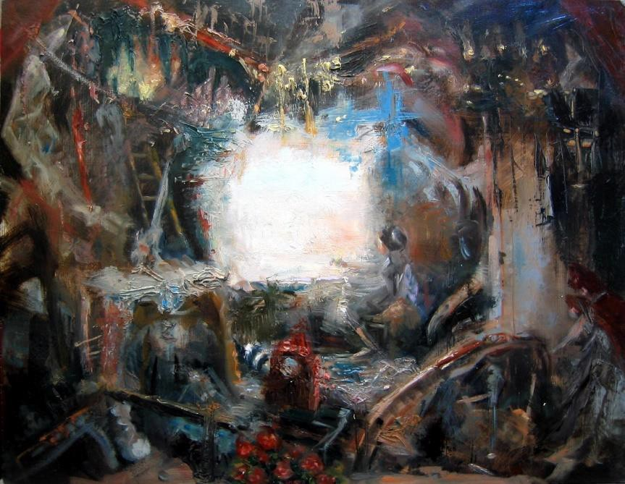

*Wish you were here*, 2007 Oil on linen

14 x 18 in. (35.6 x 45.7 cm)

Collection of Catherine Howe

To enter this work, one might imagine a story that begins “Once upon a time, there was a lonely girl who sat watching and waiting ”

In 2007, Banisadr finished both his MFA and this painting, and like much of his earlier work, it hints at narrative. While the central figure may be

surrounded by mysterious abstraction, she herself is drawn quite clearly. As often happens in Banisadr’s scenes, abstraction becomes more figurative as the viewer moves farther away from the canvas, and in *Wish you were here,* distance

seems to clarify even elements in the

surround. Banisadr denies that his paintings depict a story, but in this case, I’m afraid he protests too much.

Imagine this as a book illustration or a stage set: what stories will young schoolchildren tell about this scene? Banisadr insists on the importance of his titles—where then is “here”? Is the girl inside or outside? In a fairy- tale forest or in a cluttered chamber? If inside, has the luminous opening just now appeared? An escape

perhaps? Will she use the ladder leaning left of the opening to break free? Or perhaps she longs for the “you” of the title to materialize in the intense glow she gestures toward? Does she anticipate or just dream?

Banisadr’s composition here recalls that of Diego Velasquez’s *The Spinners* (1657), but the implied narrative is quite different. Instead of a frame filled with toiling women, this painting substitutes yearning for intention: a single figure sits idle, the center of a mysterious tale.

In interviews over the past decade, Banisadr has been very clear about his approach to composing his worldscapes: “I don’t have a focal point in the work. Every part of the painting is important. "There’s no

hierarchy” (*Interview Magazine* 2014). In this small early work, however, the luminous circle at center guides the viewer’s eye directly to the girl. She seems on a stage, with thick pigment creating a phantasmagoric

setting for her.

The strange worldscapes that Ali Banisadr conjures in paint are mediated through his wildly eclectic interests, some of which have been discussed previously. The artist is acutely sensitive to sound, and his musical

preferences run to works that are moody, impressionistic, or dissonant. A recent playlist included works by Air, Nicolás Jaar, Daft Punk, and Claude Debussy (2021). As Banisadr entitles many of his paintings with quotations from other works, it is tempting to see *Wish you were here* as an homage to the music of Pink Floyd, whose

heady, eclectic work drew on a wide array of musical influences. (Their album *Wish You Were Here* was released in 1975.) However, Banisadr himself has given no indication of this connection.

A comparison of this student painting with more recent monumental works can serve to illustrate Banisadr’s artistic development. That aside, I suspect that this work, dropping hints of a fairy-tale plot, will lead to

fascinating discussions with both adults and schoolchildren.

***The Myth Makers*, 2012** and ***Obstruction 2*, 2011**

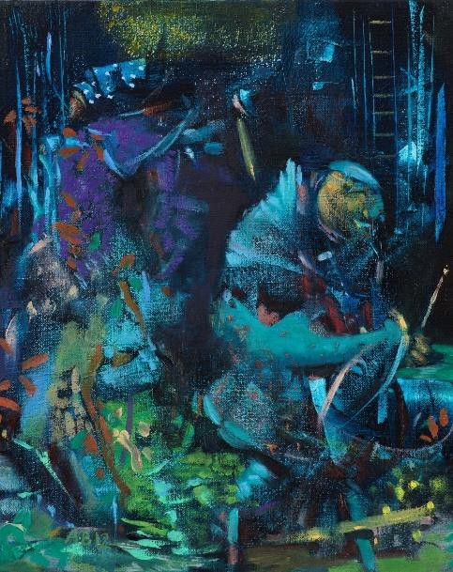*The Myth Makers* and *Obstruction 2* share little in the way of size or presentation: one is quite small, the other of generous proportion; one delivers its scene from the first row, the other from the balcony.

What they share, however, is their cool palette. Blues and greens

predominate, with a bit of purple; spots of yellow here and there appear as disrupters.

*The Myth Makers*, 2012 Oil on linen

10 x 8 in. (25.4 x 20.3 cm)

Collection of Rita and Isaac Skhaie

In creating his worldscapes, Banisadr denies that he chooses a color palette consciously. He describes his process: the work “starts very abstractly, no preliminary drawing or plan. I just begin with sound, as I said, the guiding force.” Each color has its own sound, and as they all clamor for space, the work develops organically. “When I am painting,

it’s very reactive, an accumulation of reactions and very intuitive. It’s like a dance” (*Studio International* interview 2014).

In Banisadr’s handling of red paint, the color often screams and demands attention. When blue predominates in the work, however,

things calm down. In 2020, the exhibition *Ali Banisadr: Ultramarinus—Beyond the Sea* looked at the artist’s use of that hue; the exhibition description is worth quoting at length:

“The exhibition title refers to Ultramarine, the blue colour pigment used as early as the Middle Ages, which was originally extracted from the gemstone lapis lazuli and is believed to encapsulate all shades of water and skies. Artists such as Kandinsky associated Ultramarine with the awakening of the transcendental element.

Moreover, in Eastern philosophy, this colour is linked to the sixth chakra (or “third eye”), the awakening of “elevated consciousness” (Benaki Museum, Athens).

The small painting *The Myth Makers* is comprised of blues in varying depths. As in much of Banisadr’s work, the content and narrative are gnomic. A delineated mass of light blue on the right could be read as a

character, seemingly exiting the frame, its yellow face paint applied so thinly that the dark blue ground shows

through. The figure that shares his space is only partially realized, undefined. Perhaps it is only a robe lacking a body: the full sweep of the lower half, painted in a patchwork of colors, may remind a viewer of the way Gustav Klimt juxtaposed blocks of color to shape a garment.

In the upper right background, a faint golden ladder rises out of the frame. We’ve seen ladders before in Banisadr’s ambiguous sagas: are they a link with the transcendent? An escape from the confines of the frame? But Banisadr’s intent is not to dispel ambiguity, and it would be a mistake to read the ladder as a specific “clue.” His painted worlds are not puzzles to be solved--he is, after all, himself the consummate myth maker.

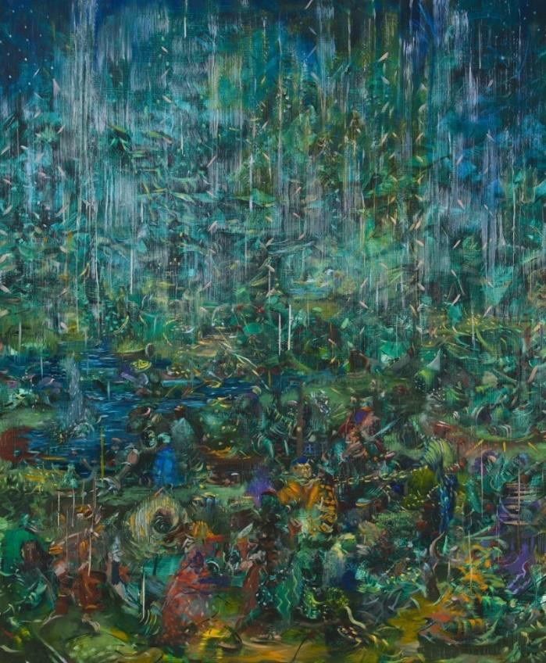A companion in color with *The Myth Makers,* the large-scale work *Obstruction* 2 (2011) uses its compositional space

differently. Despite vertical orientation, the work suggests conventional landscape planes and moves the figures downstage, as in *Aleph* (2013). Although blue and green are dominant throughout, in the scrimmage of downstage figures, pops of orange, red, and yellow punctuate the action.

*Obstruction 2*, 2011 Oil on linen

36 x 30 in. (91.4 x 76.2 cm)

Collection of Jason and Padi Nazmiyal

As we have seen in other works, foreground and sky are parted by water, apparent only on the left side of the canvas. Despite the jots of yellow creating light, vertical lines in the distant sky suggest rather heavy

rain. Remember, again, Banisadr’s insistence that his titles signify: what then is the obstruction here? Is it between the curious liminal figures seated in the foreground or is it the rain? The word “obstruction” implies a vexing difficulty, but the artist’s palette for this dynamic is nonetheless calm and untroubled.

***Contact***, **2013** and ***It’s in the Air*, 2012**

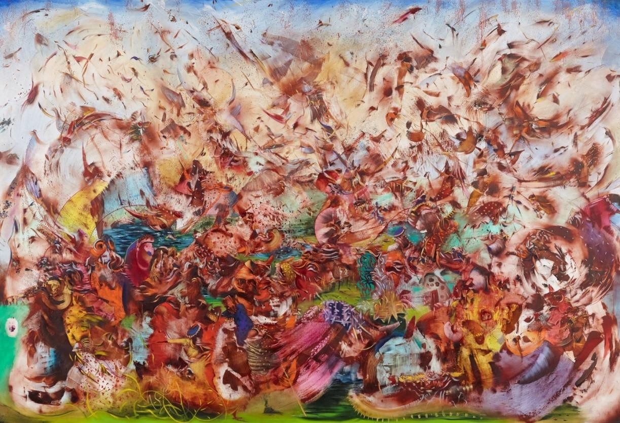

*Contact*, 2013 Oil on linen

82 x 120 in. (208.3 x 304.8 cm)

Collection Buffalo AKG Art Museum By exchange: Gift of Mrs. Georgia

M.G. Forman, Bequest of Arthur B. Michael, Elisabeth H. Gates Fund, Charles W. Goodyear and

Mrs.Seymour H. Knox, Sr., Gift of Miss Amelia E. White, 2014 2014:8

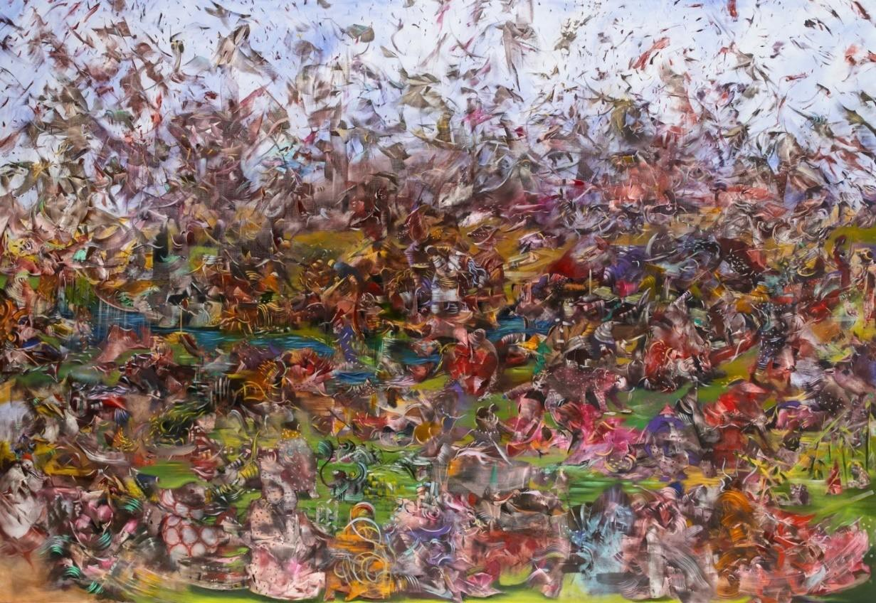*It's in the Air*, 2012 Oil on linen

82 x 120 in. (208.3 x 304.8 cm)

The Museum of Contemporary Art, Los Angeles, Gift of Thaddaeus Ropac Paris

2012.37

If not for their size, these two paintings would work well as pendants; they are certainly in thematic

conversation with one another. Recurring elements do link the works: swarms of bird-like figures flit through the paintings’ upper spaces, for example. In both, the action proceeds on what appears to be a landscape, with the expected colors representing land, sea, and sky. But their affinity has less to do with details than it does

with the whole composition.

As previously discussed, *Things Fall Apart* and *The Center Cannot Hold* emerge from Banisadr’s affinity for European art and literature. These paintings, however, have a decidedly cinematic energy. During the time he created *Contact* (2013), Banisadr was re-watching the films of Akira Kurosawa; one of the painter’s works of this period (not in *The Alchemist* exhibition) is entitled *Ran,* after Kurosawa’s epic film (1985). In *Contact,* the action seems to be unfolding in slow, stylized, cinematic motion. Banisadr tells us that the painting “is

called *Contact* because of the tension between two characters,” but identifying those characters in this crowded dance may be difficult.

In both paintings, a dynamic host of figures crowd the compositional space, frame to frame. But our view of the figures’ engagement and activity is different: *It’s in the Air,* the earlier work, manifests the action in a wider, longer view, whereas *Contact* zooms in a bit. Is that because, as the painter asserts, this work concerns two

combatants?

In both works, however, the focus is diffuse; there is no point of departure to guide the viewer through a

narrative. This decentering is intentional, as Banisadr insists that there is no “story” to his works, even while he hints at one.

Full of light and saturated color, the palette for these works hardly suggests the carnage and brutality of war. Banisadr discussed that contrast in an interview (2014):

“Beauty is such an abstract word and can go in so many directions. I’m drawn to violence in film. There’s blood and mayhem and then the sound is muted and classical music might be introduced or something beautiful that is so opposite to what’s on the screen, and that contrast is exciting to me. In Persian miniature painting, for

example, there might be a gruesome battle going on with nasty things happening, but it’s done in a beautiful way.”

Discussion of the “beautiful way” Banisadr depicts conflict differently in each of these paintings might lead to interesting comparisons. In *Contact,* the energy is more stylized, balletic; all within the frame seem to be caught up in a tornado or whirlwind. *It’s in the Air*, however, seems more beholden to the model of Persian miniatures: characters, though half-realized, are still easier to discern. Are those shining slivers in the middle ground upraised swords? Are there suggestions of medieval Japanese armor? The combatants in this painting actively engage in the fray, and the “birds” above do not hover; they seem frantic to leave the frame.

In both of these paintings, Banisadr chooses beauty over horror, even as he engages with scenes of chaos and carnage. Although for other works he has claimed influence from Picasso’s *Guernica* (1937)—that monumental rendering of the bombing of that Basque town—in these two paintings, he looks rather to cinema and Persian miniatures for inspiration. And the green grass is never bloodstained.

***Aleph*, 2013**

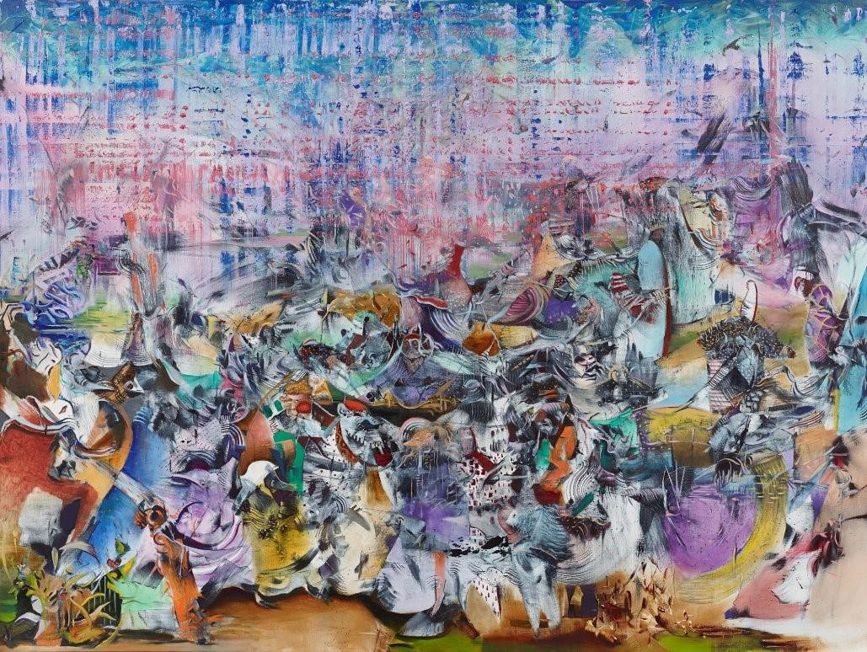*Aleph*, 2013 Oil on linen

66 x 88 in. (167.6 x 223.5 cm)

Collection of Jason and Padi Nazmiyal

“The Aleph,” a short story by the Argentine writer Jorge Luis Borges (d. 1986), describes a moment of mystical revelation; in a dark cellar, the narrator witnesses the Aleph, a point in time and space where images of all history are manifest at the same moment. He marvels, “In that single gigantic instant I saw millions of acts both delightful and awful; not one of them occupied the same point in space, without overlapping or

transparency.”

In the magical conjuring of the Aleph, Ali Banisadr finds correlation with his own artistic practice. In his painted worlds, past and present collide, with neither ascendant. Banisadr stresses the relevance of Borges’ story: the tale “fascinates me: it describes a point in a room where every point in the universe meets and can be seen from every angle simultaneously. That’s a suitable metaphor for the way I think about my paintings.

The canvas, for me, is a place where I can visually reflect on everything that happens in my life. The work doesn’t have a focal point. Every part of the painting is important. There’s no hierarchy” (Banisadr post).

Banisadr’s *Aleph* reflects his developing compositional approach, which he attributes in part to the increasing size of his canvases. The scaled-up figures, he recognized, “were demanding to be noticed more,” and they begin to crowd the foreground (Lin-Hill 54). Banisadr has always shown a heightened theatrical sense, and in *Aleph*, a viewer truly feels like audience at a performance. What might this spectacle be called--

*The Complete and Simultaneous History of the World?*

Many of the figures are fragmentary, and unlike in Borges’ Aleph, they do often overlap, seemingly struggling for their own space. Downstage center, a prominent character with a long snout bares his sharp teeth menacingly; around him, the others—in various states of becoming—seem not to notice.

In *Contact*, also painted in 2013, the upper reaches of the canvas swell with bird-like figures, a Banisadr signature seen in multiple works. In *Aleph,* however, no movement fills the upper third of the canvas. All action proceeds down and center stage; behind the drama, a wash of blue is marked with reddish lines, suggesting a backdrop or perhaps a theatrical scrim.

The Aleph of Borges and Banisadr have their name in common with the first letter of the Hebrew alphabet, the mystical symbol of divine unity. Banisadr’s attempt to realize all of human history in a single painting ends up on a stage, a place consummately appropriate for holding a mirror up to nature.

***In Medias Res*, 2015**

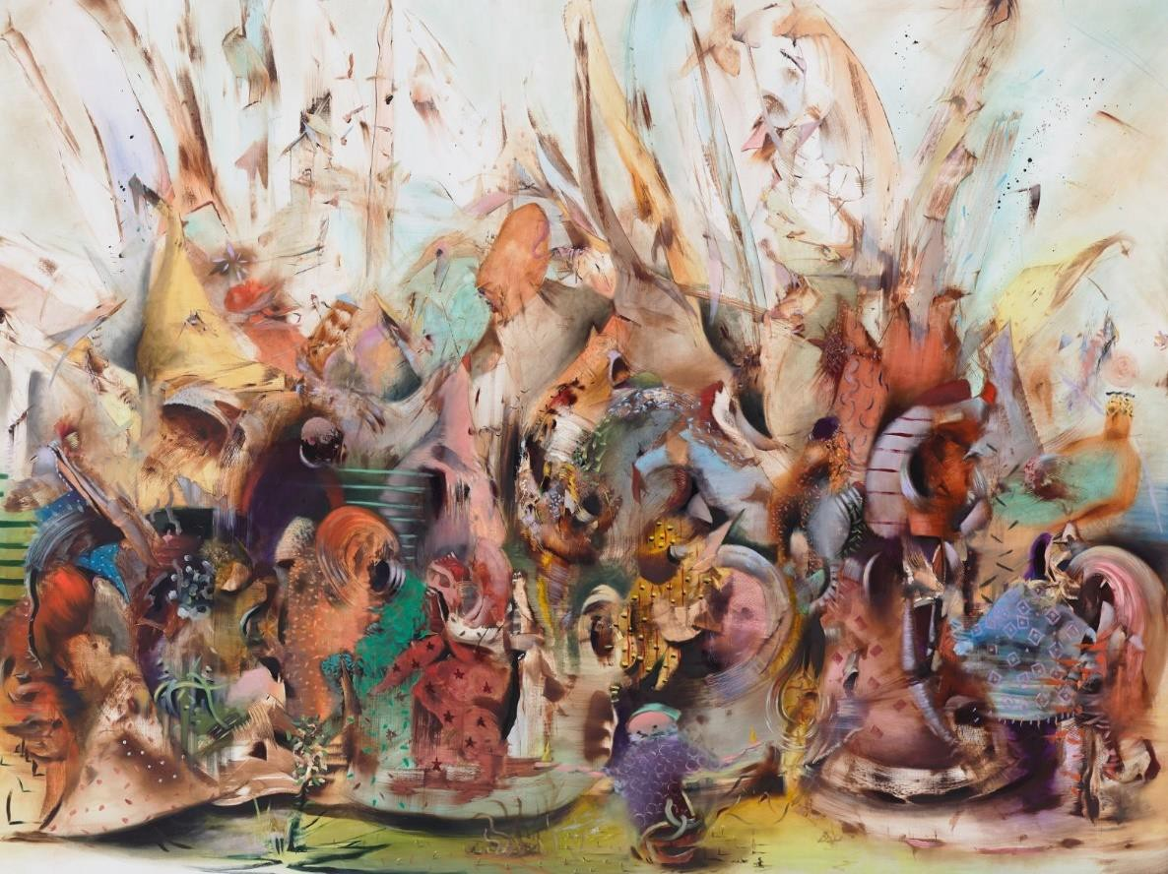*In Medias Res*, 2015 Oil on linen

66 x 88 in. (167.6 x 223.5 cm)

Private collection, Greenwich, CT

No matter what sources he has open on his research table, Ali Banisadr always begins his paintings in abstraction, with no fixed plan. As the work proceeds, he says, the formless marks begin to communicate with one another, to cluster, to emerge as coherent—though perhaps unrecognizable—shapes. His figures, midway between abstract and specific, linger in a state of becoming, *in medias res.*

Banisadr’s epic work *In Medias Res*, from 2015, seems to trick the eye: at first, we see the figures as human characters, and then, as we approach the painting, we don’t. In works like *The Myth Makers, Contact,* and

*Aleph,* Banisadr’s forms may suggest living creatures, but they read as abstractions nonetheless. This painting is different. Although the participants in this carnivalesque troupe are not familiar, they are still defined

shapes, however surreal. They might put one in mind of the strange forms in Salvador Dali’s *The Persistence of Memory* (1931); viewers can describe what each shape looks like, even if they cannot say what it is.

In a kaleidoscope of color, Banisadr presents us with a highly theatrical vision. With all characters arranged in a frieze-like formation downstage, this could possibly be a dramatic spectacle’s last big number or curtain

call. Several of the works in this exhibition feature conflict or struggle of some kind, but *In Media Res* exudes a feeling of joyful collaboration: the “characters” seem to be yakking and plotting amiably.

In the text for a Paris exhibition entitled *In Medias Res* (Thaddeus Ropac, 2015), Banisadr explained, “*In Medias Res* is a metaphor for the way my paintings are made, the way the story begins with an explosion, in the

middle of action and then it slowly unfolds and unveils its content.” Perhaps the “explosion” here is not destructive, but a creative burst of energy that leads to all the chatter.

In her notes to the exhibition catalogue plates, Elizabeth Monti suggests that the “brightly caparisoned figures” in this painting are voyagers or seekers, in the midst of a journey, and find themselves “thrown into a complex landscape with no clear sense of its contours or borders” (plate 14).

This landscape is indeed complex. Banisadr orients the image horizontally, and sections the compositional space to suggest the action takes place outdoors. The characters appear grounded—on a stage, or as Monti conceives, on “a series of curved stages suspended over green grass” (catalogue plate 14). But in the middle ground, Banisadr paints a grid of horizontal lines (as in *Exterior*, also 2015) that implies an architectural construct. Are they inside or outside? Is that a gate enclosing them?

However, one construes their story (and remember: Banisadr resists a unified narrative), these characters seem unbothered; even if their world seems upside down, they’re having fun.

***Interior*, 2015** and ***Exterior*, 2015**

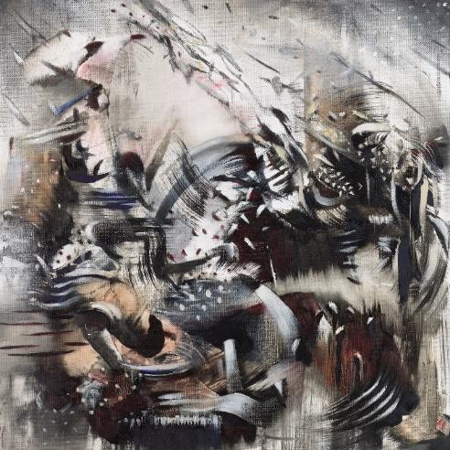When interviewed about his practice, Ali Banisadr generally leads with the sound-color nexus in his process: “When I begin a painting, it is always based on an internal sound. As soon as I apply the brush, the sound begins, and I am able to compose the work based on the sounds I hear as I’m painting.” In much of his work, those sounds lead him to employ deep, saturated colors, which vie for space in the frame until the painting “quiets down,” the term Banisadr uses to indicate that a work is completed.

*Interior*, 2015 Oil on linen

16 x 16 in. (40.6 x 40.6 cm)

Collection of the artist

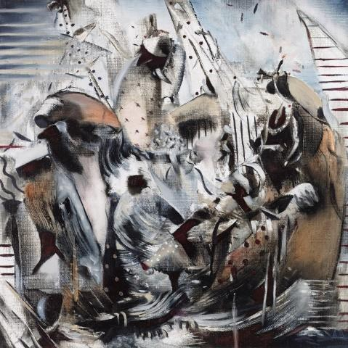

*Exterior*, 2015 Oil on linen

16 x 16 in. (40.6 x 40.6 cm)

Collection of the artist

Some of his smaller works, however, rely less on his symphony of color. In this exhibition, we have a handful of monochrome images: the untitled charcoal and ink sketches (2006), and the pastels from 2022. More sparce than his populous worldscapes, these sketches are also less abstract,

portraying recognizable shapes and figures.

*Interior* and *Exterior*, however, are different. These two companion images are rendered in oil on square linen, and their depictions seem to lean more towards abstraction. In each, a kinetic swirl of neutral colors provides only vague suggestions of subject matter or narrative. In these works, he shows his reverence for his Surrealist and Abstract Expressionist forebears, who painted but did not explain.

In looking at these works on a tour, docents might begin with the paradox of titles. *Exterior* is largely contained within the frame: a trio of strange shapes is set against a grid of horizontal lines (inspired, the artist says, by the rolling metal security doors on urban storefronts). The nebulous forms in *Interior*, however, seem to be straining to escape their compositional space.

In her notes for the exhibition catalog plate, curator Elizabeth Monti describes that contradiction. As noted previously, Banisadr’s study of Jungian psychology leads him to reference archetypes, dreams, myth, alchemy, and the occult in his art. The “primordial creatures” of *Exterior* can be seen perhaps as visual realizations of

“the three components of the human psyche: the ego, the personal unconscious, and the collective unconscious.” *Interior*, she contends, “reflects the elements of the collective unconscious, a repository of

dreams, myths, symbols, and motifs that transcend culture and generation.” But whereas *Exteriors* conjures up an architectural space, the “kinetic, curving forms of *Interiors* evoke a wind-blown, untamed outdoor world” (Notes, plates 16 and 17). Should the titles not be reversed?

But Banisadr’s visual language is never literal, and your guests may see these paintings not in psychological terms at all. They may see them as intriguing studies in black and white, grey and brown. Discuss.